4. Results and Discussion
This section reports the corrected results after repairing the pipeline issues identified in analysis.md: same-visit condition leakage was removed, geographic and climate-zone proxy features were excluded from the primary design models, section-level bootstrapping was corrected, and monitoring-vs-persistence comparisons were recomputed on identical rows. The findings therefore emphasize transferability, benchmark skill, and explanation stability rather than optimistic fit.

4.1 Dataset and Preprocessing Summary (§3.1-§3.7)
The processed LTPP extract contains 4397 raw rows spanning 1989-01-01 to 2021-02-11. After target-specific filtering, thresholding, feature screening, and section-based splitting, the design datasets remain small and regionally imbalanced. This matters because the article's central question is not only whether ensembles fit pooled data, but whether their fitted relationships survive climate and regional transfer.
Table 4.1. Target-specific rows retained after preprocessing and splitting.
Target | Feature rows | Visit rows | Train rows | Validation rows | Test rows
IRI | 650 | 650 | 455 | 109 | 86
Rutting | 566 | 566 | 410 | 82 | 74
Distress | 378 | 378 | 272 | 61 | 45

Table 4.2. Section-level train/validation/test allocation by region.
Region | Train | Validation | Test | Total
Arizona | 16 | 3 | 3 | 22
Georgia | 8 | 2 | 2 | 12
Ohio | 5 | 1 | 1 | 7
Ontario | 5 | 1 | 1 | 7

4.2 Pre-Specified Consistency Checks (§3.13)
The repaired pipeline is evaluated with explicit consistency checks rather than with the most optimistic model alone. These checks target the exact failure modes identified in the analysis: same-visit leakage, persistence dominance, climate transfer failure, and unstable explanations.
Table 4.3. Corrected consistency checks.
Check | Evidence | Interpretation
Leakage sentinel | XGB design distress R2 = 0.278 | Near-perfect distress accuracy disappeared after same-visit distress indicators were removed.
Persistence benchmark | Common-set XGB IRI R2 = --; persistence R2 = 0.853 | Monitoring performance is not automatically useful unless it beats persistence on identical rows.
Regional transfer | Ontario XGB LOO R2 = -0.223 | The corrected analysis does not support the old positive Ontario-transfer claim.
Explanation stability | SHAP rank rho = 0.681; threshold = 0.750 | Interpretability is useful descriptively, but the feature ranking is below the pre-specified stability threshold.

4.3 Benchmark Model Performance (§3.9)
The benchmark models define the minimum bar for the machine-learning models. Mean and age-only baselines test whether a target can be explained by simple central tendency or time-in-service, while Ridge tests whether a linear regularized model already captures the useful signal. Persistence benchmarks are reported separately because they are monitoring-task baselines.
Table 4.4. Benchmark performance on held-out test rows.
Benchmark | N | R2 | RMSE | MAE
MEAN Design IRI | 86 | -0.000 | 0.513 | 0.371
AASHTO Design IRI | 86 | -0.004 | 0.514 | 0.369
RIDGE Design IRI | 86 | 0.041 | 0.503 | 0.363
MEAN Monitoring IRI | 66 | -0.018 | 0.511 | 0.371
AASHTO Monitoring IRI | 66 | -0.021 | 0.512 | 0.368
RIDGE Monitoring IRI | 66 | -0.044 | 0.517 | 0.372
MEAN Design Rutting | 74 | -0.076 | 3.200 | 2.706
RIDGE Design Rutting | 74 | 0.378 | 2.433 | 1.802
MEAN Monitoring Rutting | 47 | -0.124 | 3.210 | 2.639
RIDGE Monitoring Rutting | 47 | 0.246 | 2.630 | 1.973
MEAN Design Distress | 45 | -0.051 | 22.892 | 20.012
RIDGE Design Distress | 45 | 0.093 | 21.264 | 18.756
MEAN Monitoring Distress | 26 | -0.021 | 22.482 | 19.793
RIDGE Monitoring Distress | 26 | 0.157 | 20.429 | 17.625

4.4 Ensemble Model Test-Set Performance (§3.10-§3.11.2)
After removing same-visit condition features and geographic proxies, ensemble performance is much less inflated. XGBoost design IRI reaches R2 = 0.158, while XGBoost design distress reaches R2 = 0.278 rather than the near-perfect result in the old document. XGBoost monitoring IRI reaches R2 = 0.451, but this is expected to benefit from lagged condition information and must be judged against persistence.
Table 4.5. Corrected ensemble test-set performance with section-bootstrap intervals.
Target | Task | Model | Rows | Sections | R2 | R2 CI lower | R2 CI upper | RMSE | MAE
IRI | Design | XGB | 86 | 7 | 0.158 | -0.287 | 0.424 | 0.471 | 0.300
IRI | Design | RF | 86 | 7 | 0.130 | -0.202 | 0.368 | 0.479 | 0.311
IRI | Monitoring | XGB | 66 | 7 | 0.451 | 0.321 | 0.564 | 0.375 | 0.210
IRI | Monitoring | RF | 66 | 7 | 0.469 | 0.331 | 0.661 | 0.369 | 0.191
Rutting | Design | XGB | 74 | 7 | 0.432 | -0.023 | 0.625 | 2.325 | 1.758
Rutting | Design | RF | 74 | 7 | 0.394 | -0.251 | 0.532 | 2.401 | 1.870
Rutting | Monitoring | XGB | 47 | 7 | 0.672 | 0.187 | 0.766 | 1.734 | 1.278
Rutting | Monitoring | RF | 47 | 7 | 0.592 | -0.012 | 0.747 | 1.935 | 1.477
Distress | Design | XGB | 45 | 7 | 0.278 | -0.386 | 0.714 | 18.976 | 14.228
Distress | Design | RF | 45 | 7 | 0.210 | -0.517 | 0.658 | 19.843 | 15.708
Distress | Monitoring | XGB | 26 | 7 | 0.762 | 0.421 | 0.960 | 10.857 | 6.949
Distress | Monitoring | RF | 26 | 7 | 0.741 | 0.473 | 0.909 | 11.319 | 8.460

4.4.1 Regime-Split Rutting Models
The old chapter treated warm/freeze rutting splits as a fault-specific repair. The corrected pipeline no longer elevates that post-hoc split to a primary result because the article's main methodology emphasizes pre-specified target, task, and regional-transfer evaluations. Any future regime split should be reintroduced only as a pre-registered sensitivity analysis with held-out section counts and uncertainty intervals.

4.5 Monitoring Task vs. Persistence Benchmarks (§3.9 Common Set)
Monitoring models are compared with persistence on the same section/date rows. This prevents an optimistic comparison where a trained model and a naive baseline are evaluated on different data. On the common IRI set, absolute XGBoost monitoring has skill_vs_persist_k1 = --, while the delta-IRI sensitivity model has skill_vs_persist_k1 = --.
Table 4.6. Common-set monitoring and persistence comparison.
Model | N | R2 | RMSE | MAE | Skill vs k=1 persistence
PERSIST K1 Common IRI | 32 | 0.853 | 0.211 | 0.120 | --
PERSIST K2 Common IRI | 32 | 0.853 | 0.211 | 0.120 | --
PERSIST K3 Common IRI | 32 | 0.853 | 0.211 | 0.120 | --
XGB Monitoring Common IRI | 32 | 0.733 | 0.284 | 0.178 | --
RF Monitoring Common IRI | 32 | 0.727 | 0.287 | 0.162 | --
XGB Monitoring Delta Common IRI | 32 | 0.940 | 0.134 | 0.100 | 0.363
RF Monitoring Delta Common IRI | 32 | 0.957 | 0.114 | 0.081 | 0.458
PERSIST K1 Common Rutting | 22 | 0.810 | 1.492 | 0.955 | --
PERSIST K2 Common Rutting | 22 | 0.810 | 1.492 | 0.955 | --
PERSIST K3 Common Rutting | 22 | 0.810 | 1.492 | 0.955 | --
XGB Monitoring Common Rutting | 22 | 0.787 | 1.579 | 1.302 | --
RF Monitoring Common Rutting | 22 | 0.712 | 1.837 | 1.498 | --
PERSIST K1 Common Distress | 6 | -0.467 | 30.608 | 17.833 | --
PERSIST K2 Common Distress | 6 | -0.467 | 30.608 | 17.833 | --
PERSIST K3 Common Distress | 6 | -0.467 | 30.608 | 17.833 | --
XGB Monitoring Common Distress | 6 | 0.711 | 13.595 | 9.475 | --
RF Monitoring Common Distress | 6 | 0.699 | 13.870 | 11.715 | --

4.5.1 Delta IRI Monitoring - Forecast Skill over Persistence
The delta formulation predicts deterioration increments and then maps the prediction back to the absolute IRI scale using the lagged condition. This is a useful sensitivity because it separates forecasting deterioration from simply reconstructing the lag. It should still be interpreted as a monitoring result, not a design-stage transfer result.

4.6 Leave-One-Region-Out Generalisation (§3.11.3)
Leave-one-region-out validation is the clearest stress test for the article's transferability argument. The corrected Ontario XGBoost LOO R2 is -0.223, and Georgia XGBoost LOO R2 is -0.766. These failures are not cosmetic; they show that pooled accuracy does not guarantee transportable pavement-deterioration relationships.
Table 4.7. Leave-one-region-out IRI design validation.
Withheld region | Model | Target | Rows | R2 | RMSE | MAE
Arizona | xgb | iri | 295 | -0.079 | 0.495 | 0.368
Arizona | rf | iri | 295 | 0.026 | 0.471 | 0.353
Georgia | xgb | iri | 96 | -0.766 | 0.367 | 0.328
Georgia | rf | iri | 96 | -0.701 | 0.360 | 0.317
Ohio | xgb | iri | 148 | 0.061 | 0.481 | 0.382
Ohio | rf | iri | 148 | -0.052 | 0.509 | 0.394
Ontario | xgb | iri | 111 | -0.223 | 0.495 | 0.370
Ontario | rf | iri | 111 | -0.140 | 0.478 | 0.339

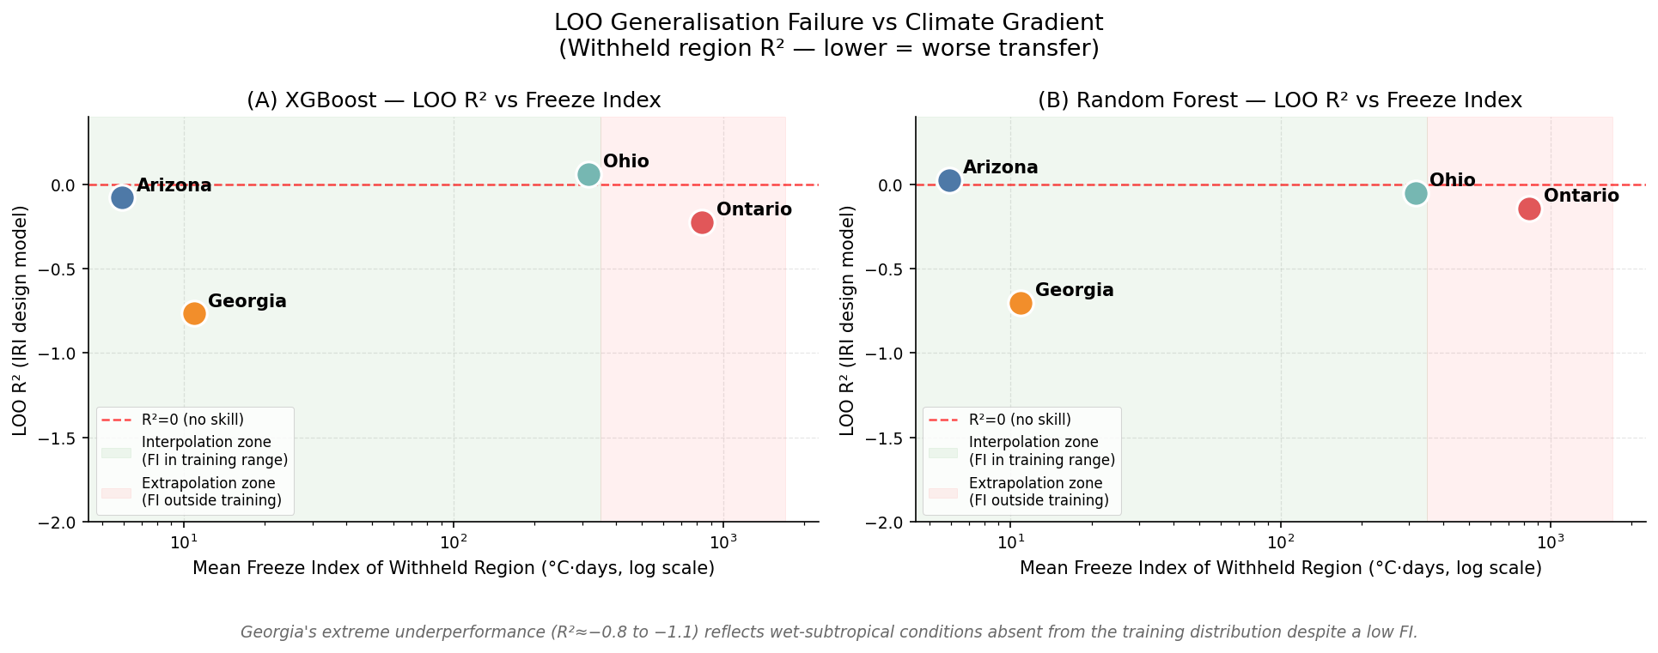
Figure 4.1. LOO R2 across the climate gradient.
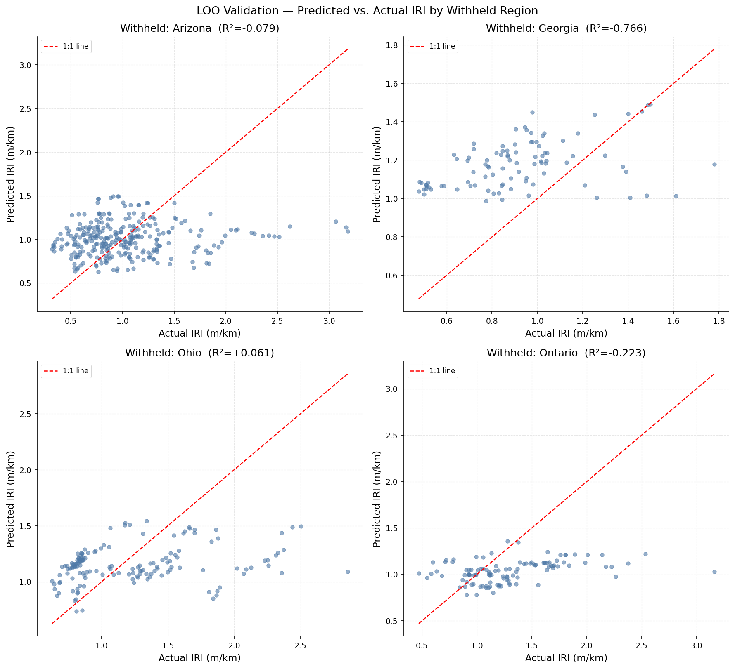
Figure 4.2. Observed versus predicted IRI under LOO validation.

4.6.1 Ontario Section-Level Sensitivity (§3.11.3)
Ontario section-level results are retained as exploratory diagnostics only. Most sections have fewer than 30 observations, so these rows should identify failure patterns rather than support strong inferential claims.
Table 4.8. Ontario section-level LOO sensitivity.
Section | Freeze-index group | Mean FI | Rows | Model | R2 | Note
Ontario_1622 | high | 863.700 | 29 | xgb | 0.010 | exploratory — no CI, < 30 obs
Ontario_1622 | high | 863.700 | 29 | rf | 0.062 | exploratory — no CI, < 30 obs
Ontario_1680 | moderate | 600.900 | 18 | xgb | -0.548 | exploratory — no CI, < 30 obs
Ontario_1680 | moderate | 600.900 | 18 | rf | -0.167 | exploratory — no CI, < 30 obs
Ontario_1806 | moderate | 598.400 | 18 | xgb | 0.048 | exploratory — no CI, < 30 obs
Ontario_1806 | moderate | 598.400 | 18 | rf | 0.012 | exploratory — no CI, < 30 obs
Ontario_960 | extreme | 1222.100 | 9 | xgb | -0.252 | exploratory — no CI, < 30 obs
Ontario_960 | extreme | 1222.100 | 9 | rf | -0.293 | exploratory — no CI, < 30 obs
Ontario_961 | extreme | 1225.600 | 9 | xgb | -0.910 | exploratory — no CI, < 30 obs
Ontario_961 | extreme | 1225.600 | 9 | rf | -0.557 | exploratory — no CI, < 30 obs
Ontario_903 | extreme | 1225.600 | 10 | xgb | 0.496 | exploratory — no CI, < 30 obs
Ontario_903 | extreme | 1225.600 | 10 | rf | 0.105 | exploratory — no CI, < 30 obs
Ontario_1620 | moderate | 604.600 | 18 | xgb | -0.023 | exploratory — no CI, < 30 obs
Ontario_1620 | moderate | 604.600 | 18 | rf | -0.124 | exploratory — no CI, < 30 obs

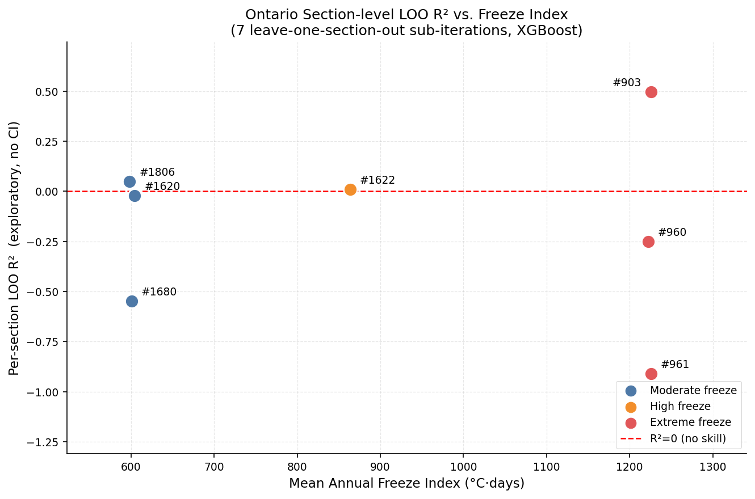
Figure 4.3. Ontario section-level LOO sensitivity.

4.7 Residual Diagnostics (§3.11.4)
Residual diagnostics were regenerated after the leakage and bootstrap corrections. They are used to assess heteroscedasticity, regional bias, and systematic misspecification in the corrected XGBoost IRI design model. The figure should be read alongside the weak LOO results: residual structure is another warning that pooled test performance is not enough.
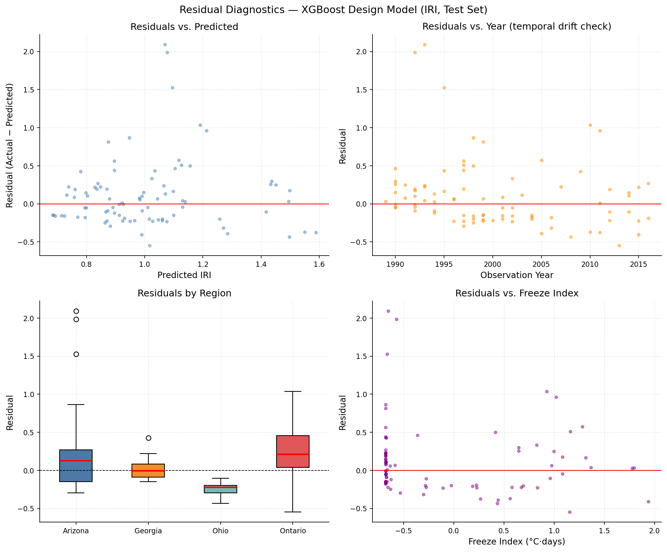
Figure 4.4. Residual diagnostics for corrected XGBoost IRI design predictions.

4.8 SHAP TreeExplainer (§3.12.1)
SHAP explanations were regenerated for the corrected design model. The cross-model rank correlation is rho = 0.681, below the pre-specified threshold of 0.750. Consequently, SHAP is reported as model-behavior evidence and not as causal attribution.

4.8.1 Global Feature Importance
Table 4.9. Top corrected XGBoost IRI design SHAP features.
Rank | Feature | Mean |SHAP|
1 | TRF_REP_REP_ESAL_PER_VEH_CLASS_12 | 0.042
2 | L05B_REPR_THICKNESS | 0.040
3 | LAYER_COUNT_AC | 0.040
4 | FEAT_AGE_YEARS | 0.036
5 | L05B_DESCRIPTION | 0.026
6 | COMP_AGE_CLIMATE | 0.026
7 | TRF_REP_REP_ESAL_TANDEM_AXLE | 0.024
8 | L05B_MATL_CODE | 0.023
9 | UB_SUP_REPR_THICKNESS | 0.022
10 | TRF_AADTT_VEH_CLASS_4_TREND | 0.021
11 | AC_NO_10_PASSING | 0.021
12 | LAYER_THICKNESS_AC_MM | 0.016
13 | AC_ASPHALT_CONTENT_MEAN | 0.016
14 | AC_BSG | 0.014
15 | LAYER_SURFACE_MATL_CODE | 0.013

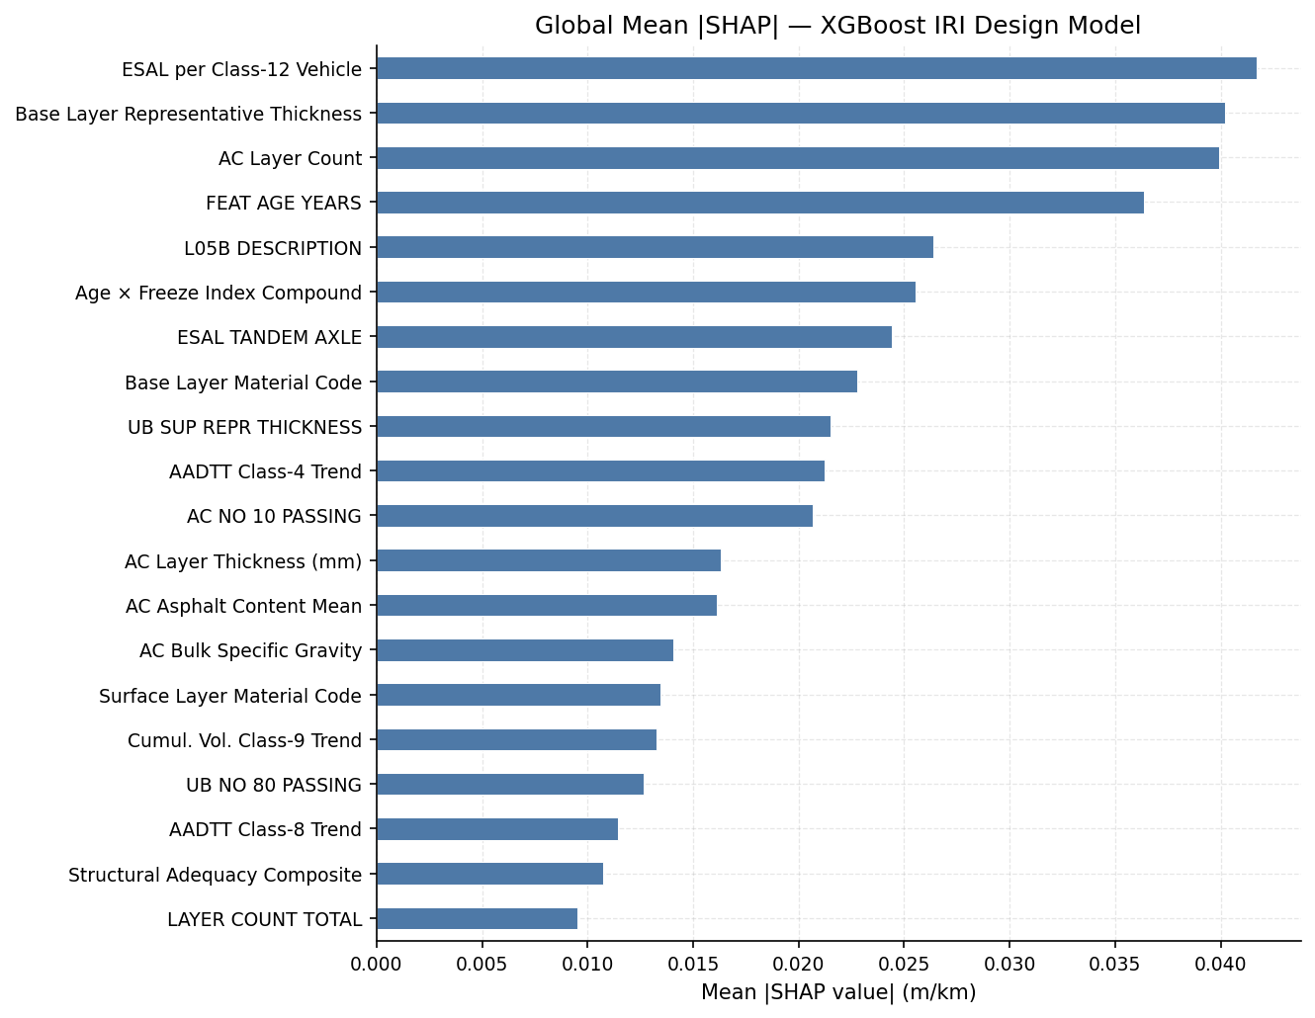
Figure 4.5. Global SHAP bar plot for corrected XGBoost IRI design.
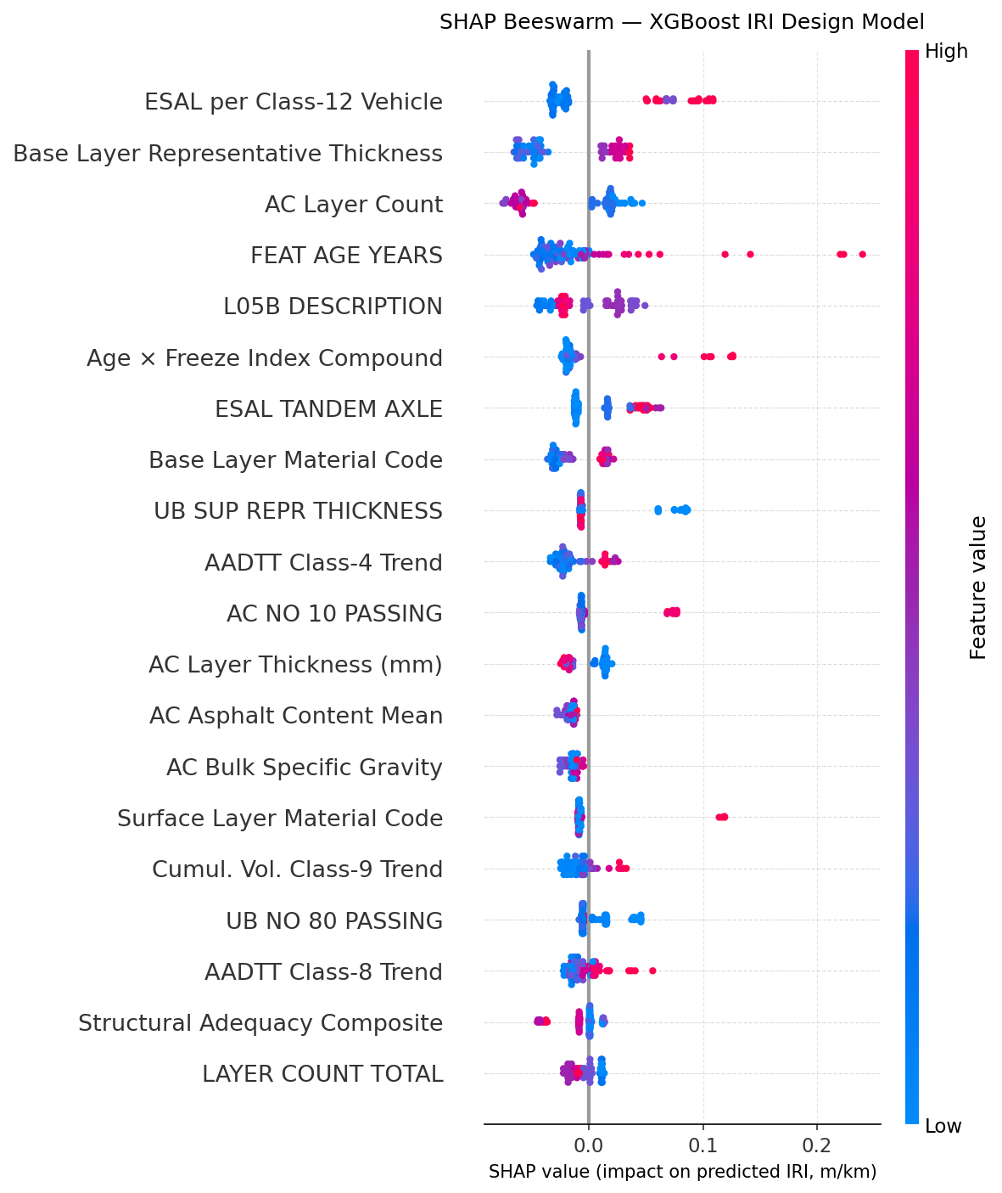
Figure 4.6. SHAP beeswarm for corrected XGBoost IRI design.

4.8.2 Waterfall Decomposition by Region (§3.12.1)
The waterfall plots illustrate individual regional predictions. They are useful for auditing how a model assembles one prediction, but they should not be generalized beyond the local examples.
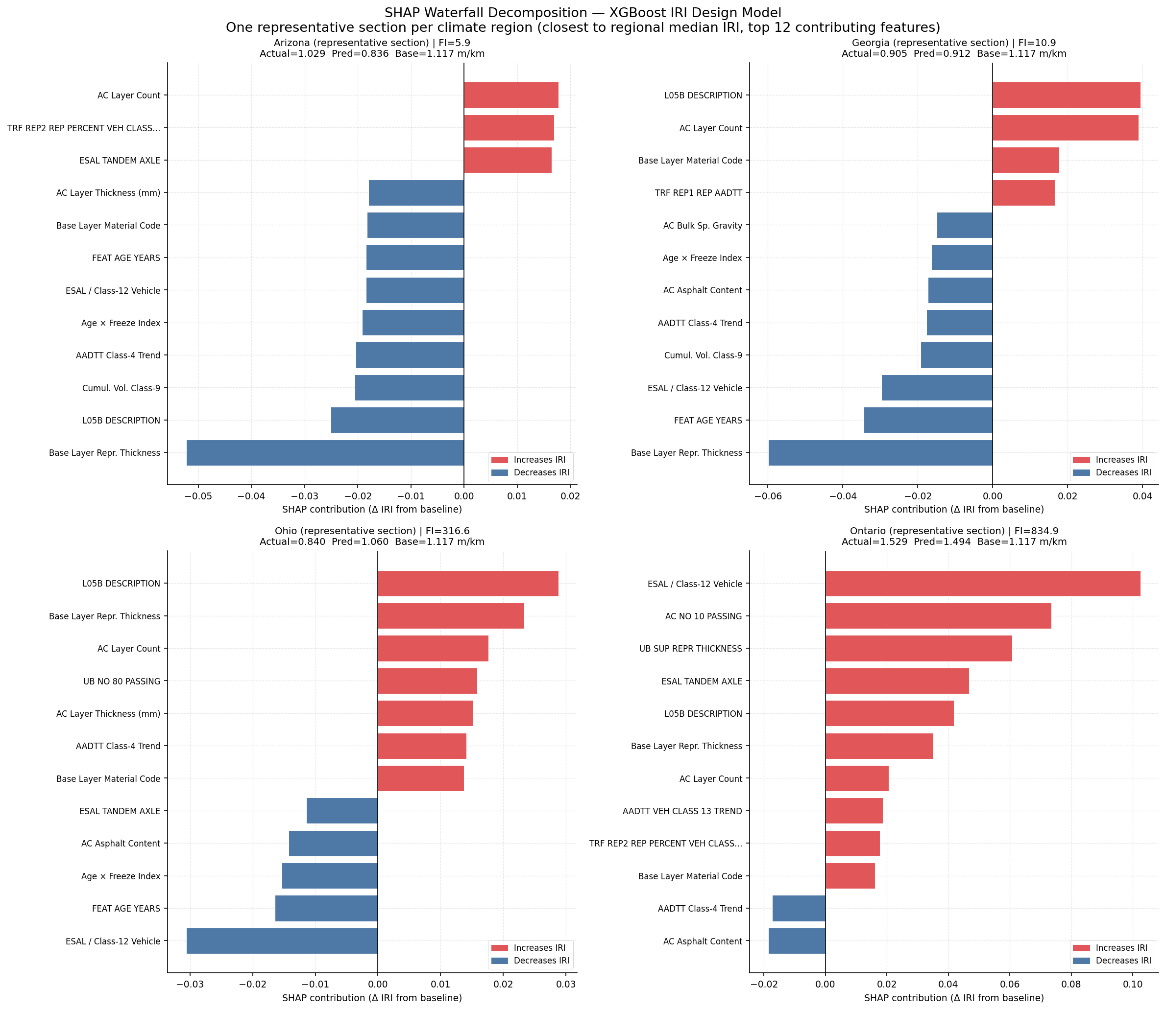
Figure 4.7. Regional SHAP waterfall examples.

4.8.3 Regional SHAP Stratification (§3.12.1)
Regional SHAP summaries expose changes in model reliance across climates and agencies. These patterns are descriptive and must be reconciled with the poor LOO transfer before being used in engineering interpretation.
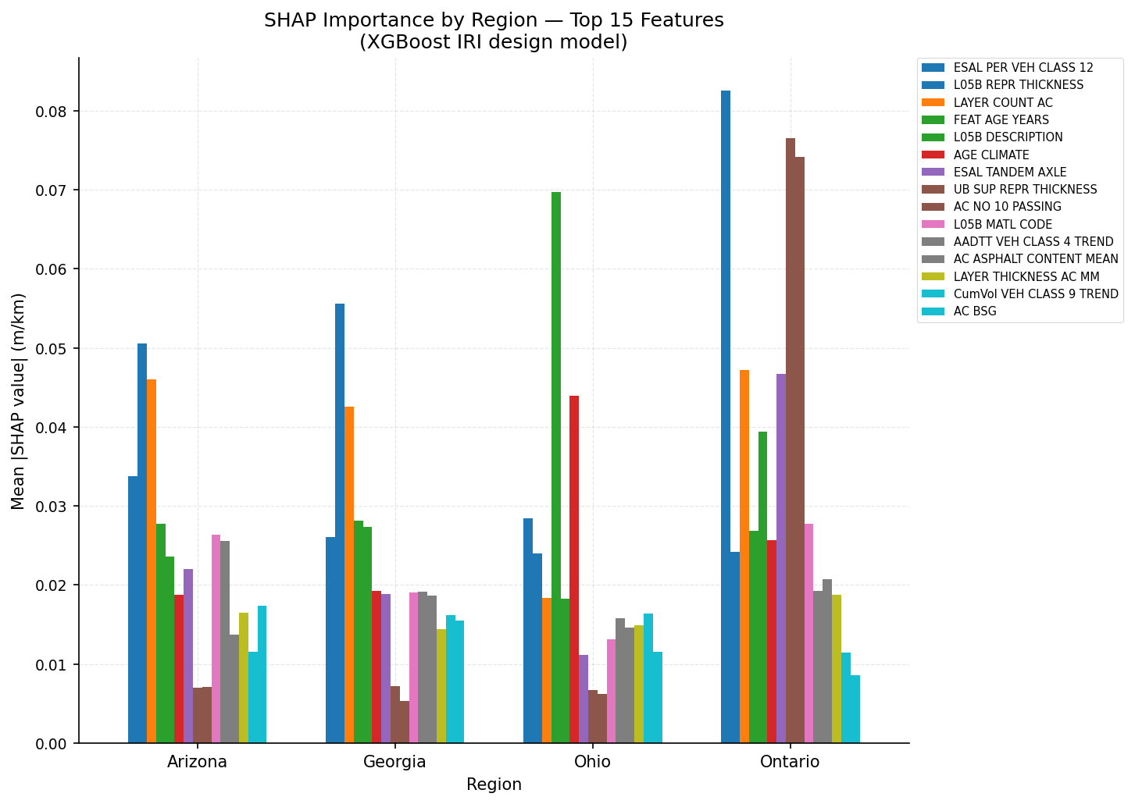
Figure 4.8. Regional SHAP summary.
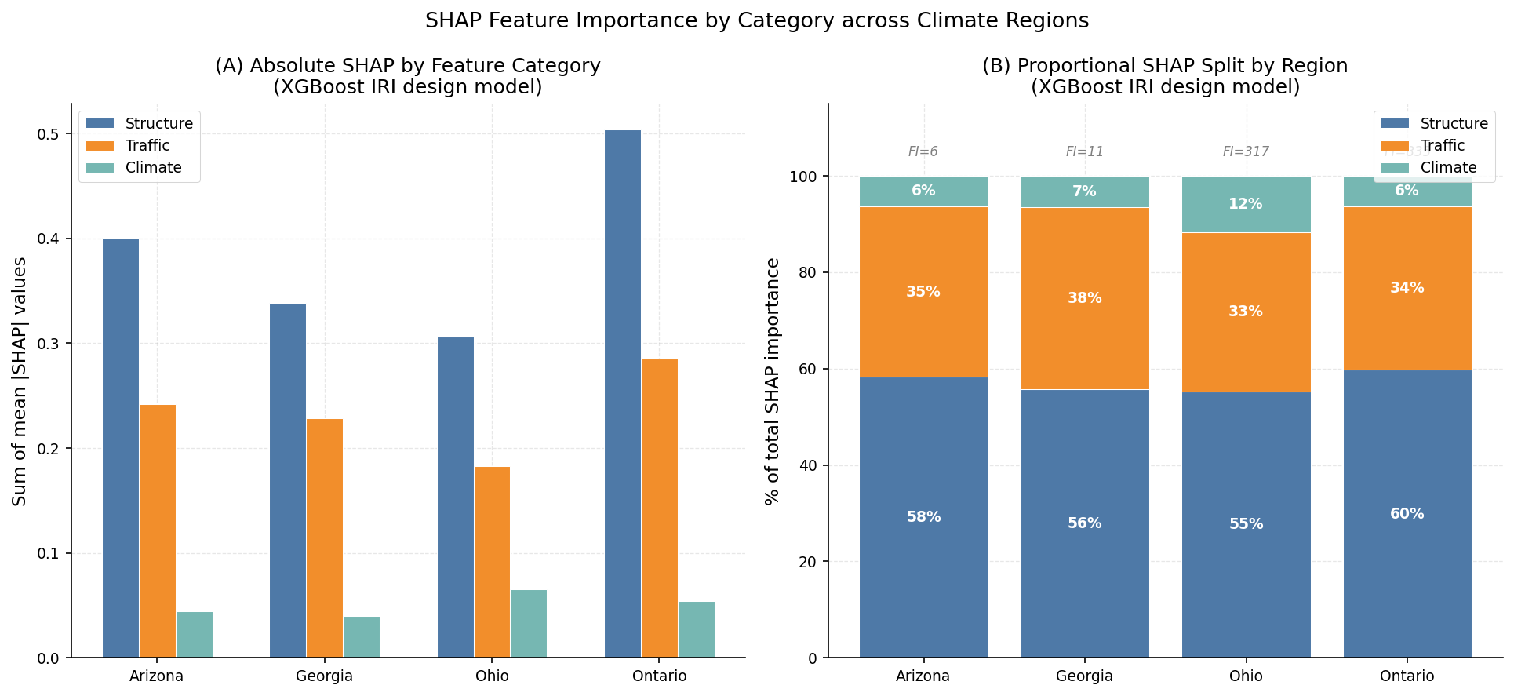
Figure 4.9. SHAP category contributions by region.
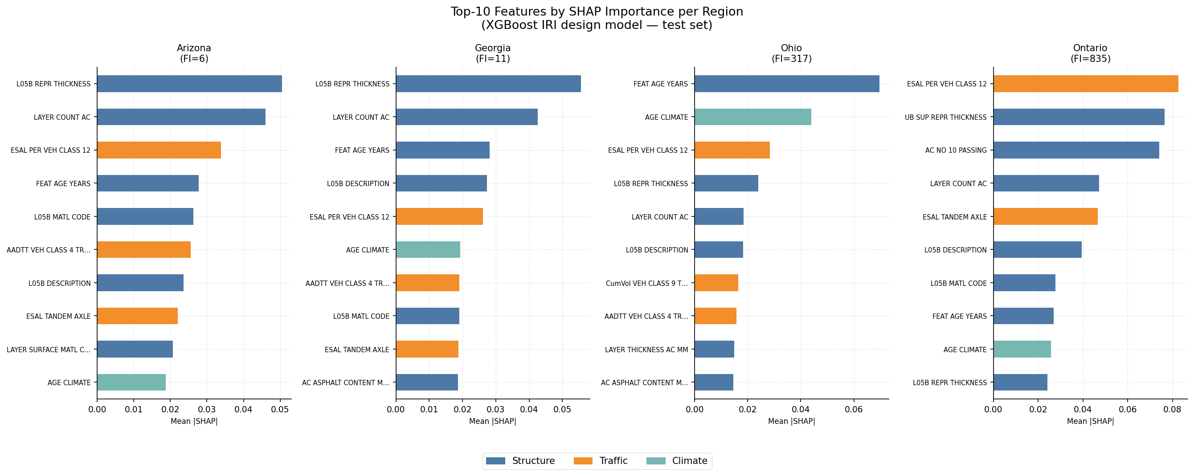
Figure 4.10. Region-specific top SHAP features.

4.8.4 Cross-Model SHAP Consistency (§3.12.2)
Table 4.10. Cross-model SHAP rank consistency.
Features | Spearman rho | p-value | Threshold | Status
155 | 0.681 | 0.000 | 0.750 | UNSTABLE (ρ = 0.6808 < 0.75) — robust claims restricted to top-ranking converging features

4.9 Partial Dependence Analysis (§3.12.3)
Partial dependence plots summarize fitted response surfaces for selected predictors. Because the model does not transfer reliably across regions, these plots are interpreted as internal model diagnostics rather than universal pavement-performance curves.
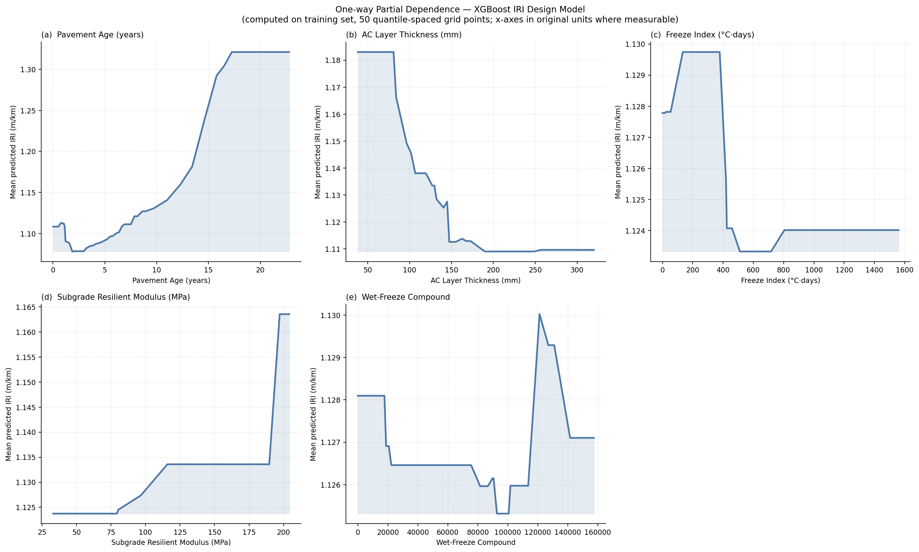
Figure 4.11. One-way partial dependence diagnostics.
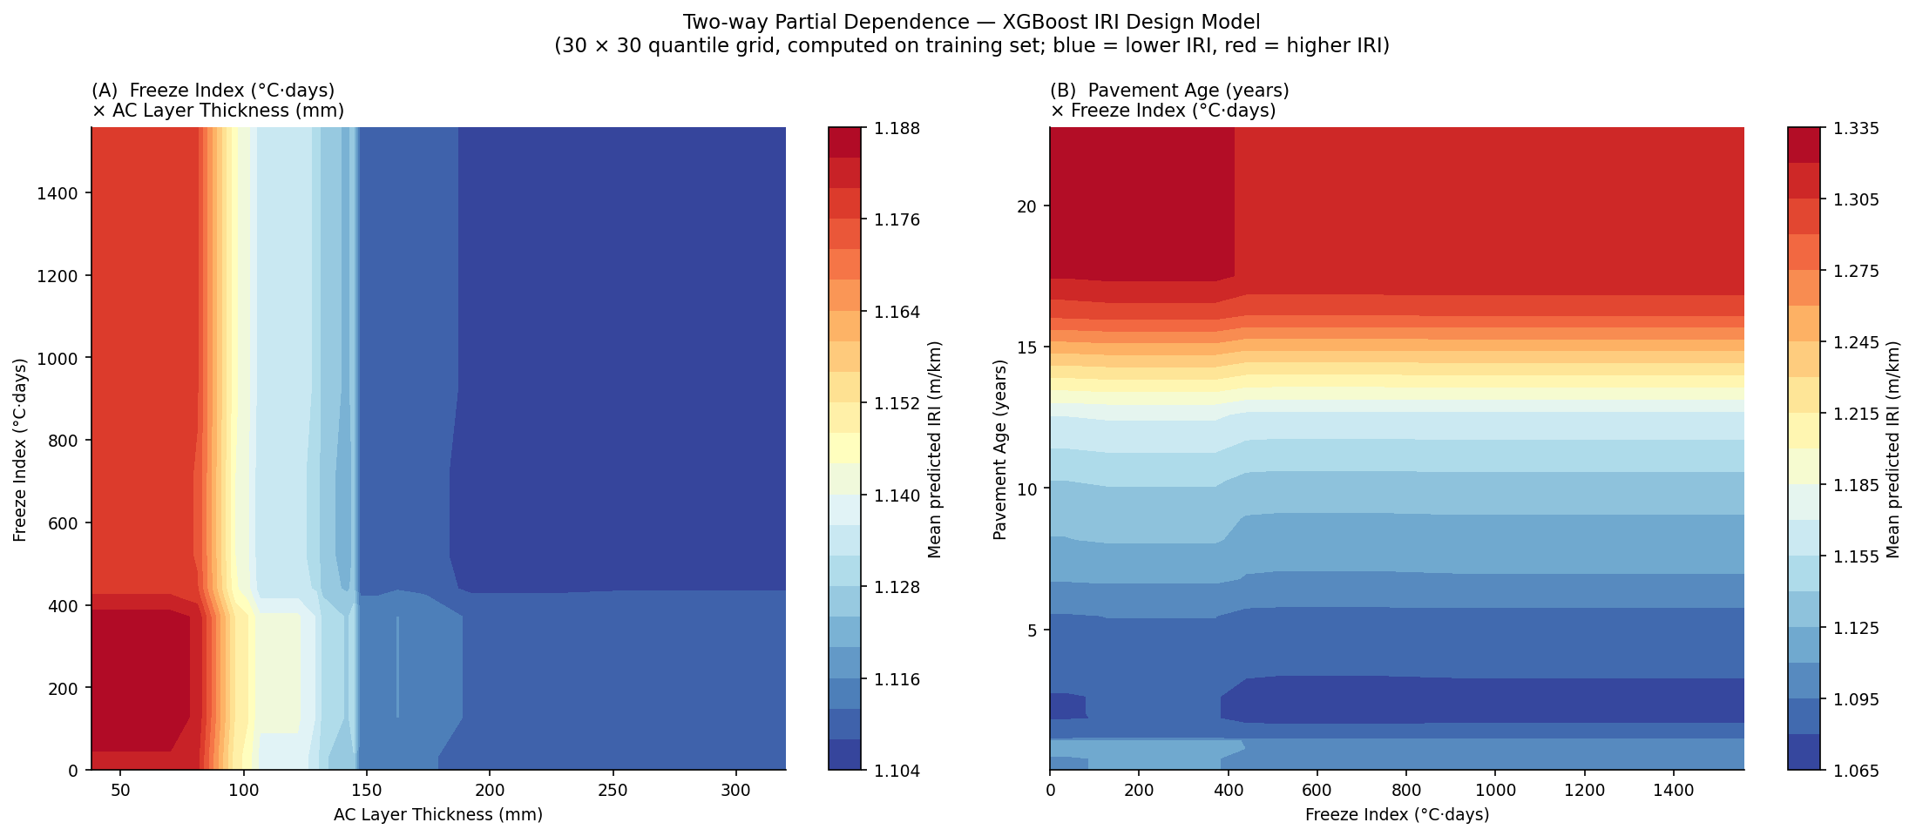
Figure 4.12. Two-way partial dependence diagnostics.

4.10 Regional Climate, Traffic, and Deterioration Profile
The regional profile contextualizes why a pooled model may fail under LOO validation. Differences in freeze index, precipitation, traffic loading, and deterioration distributions create a transfer problem that cannot be solved by in-sample explanation alone.
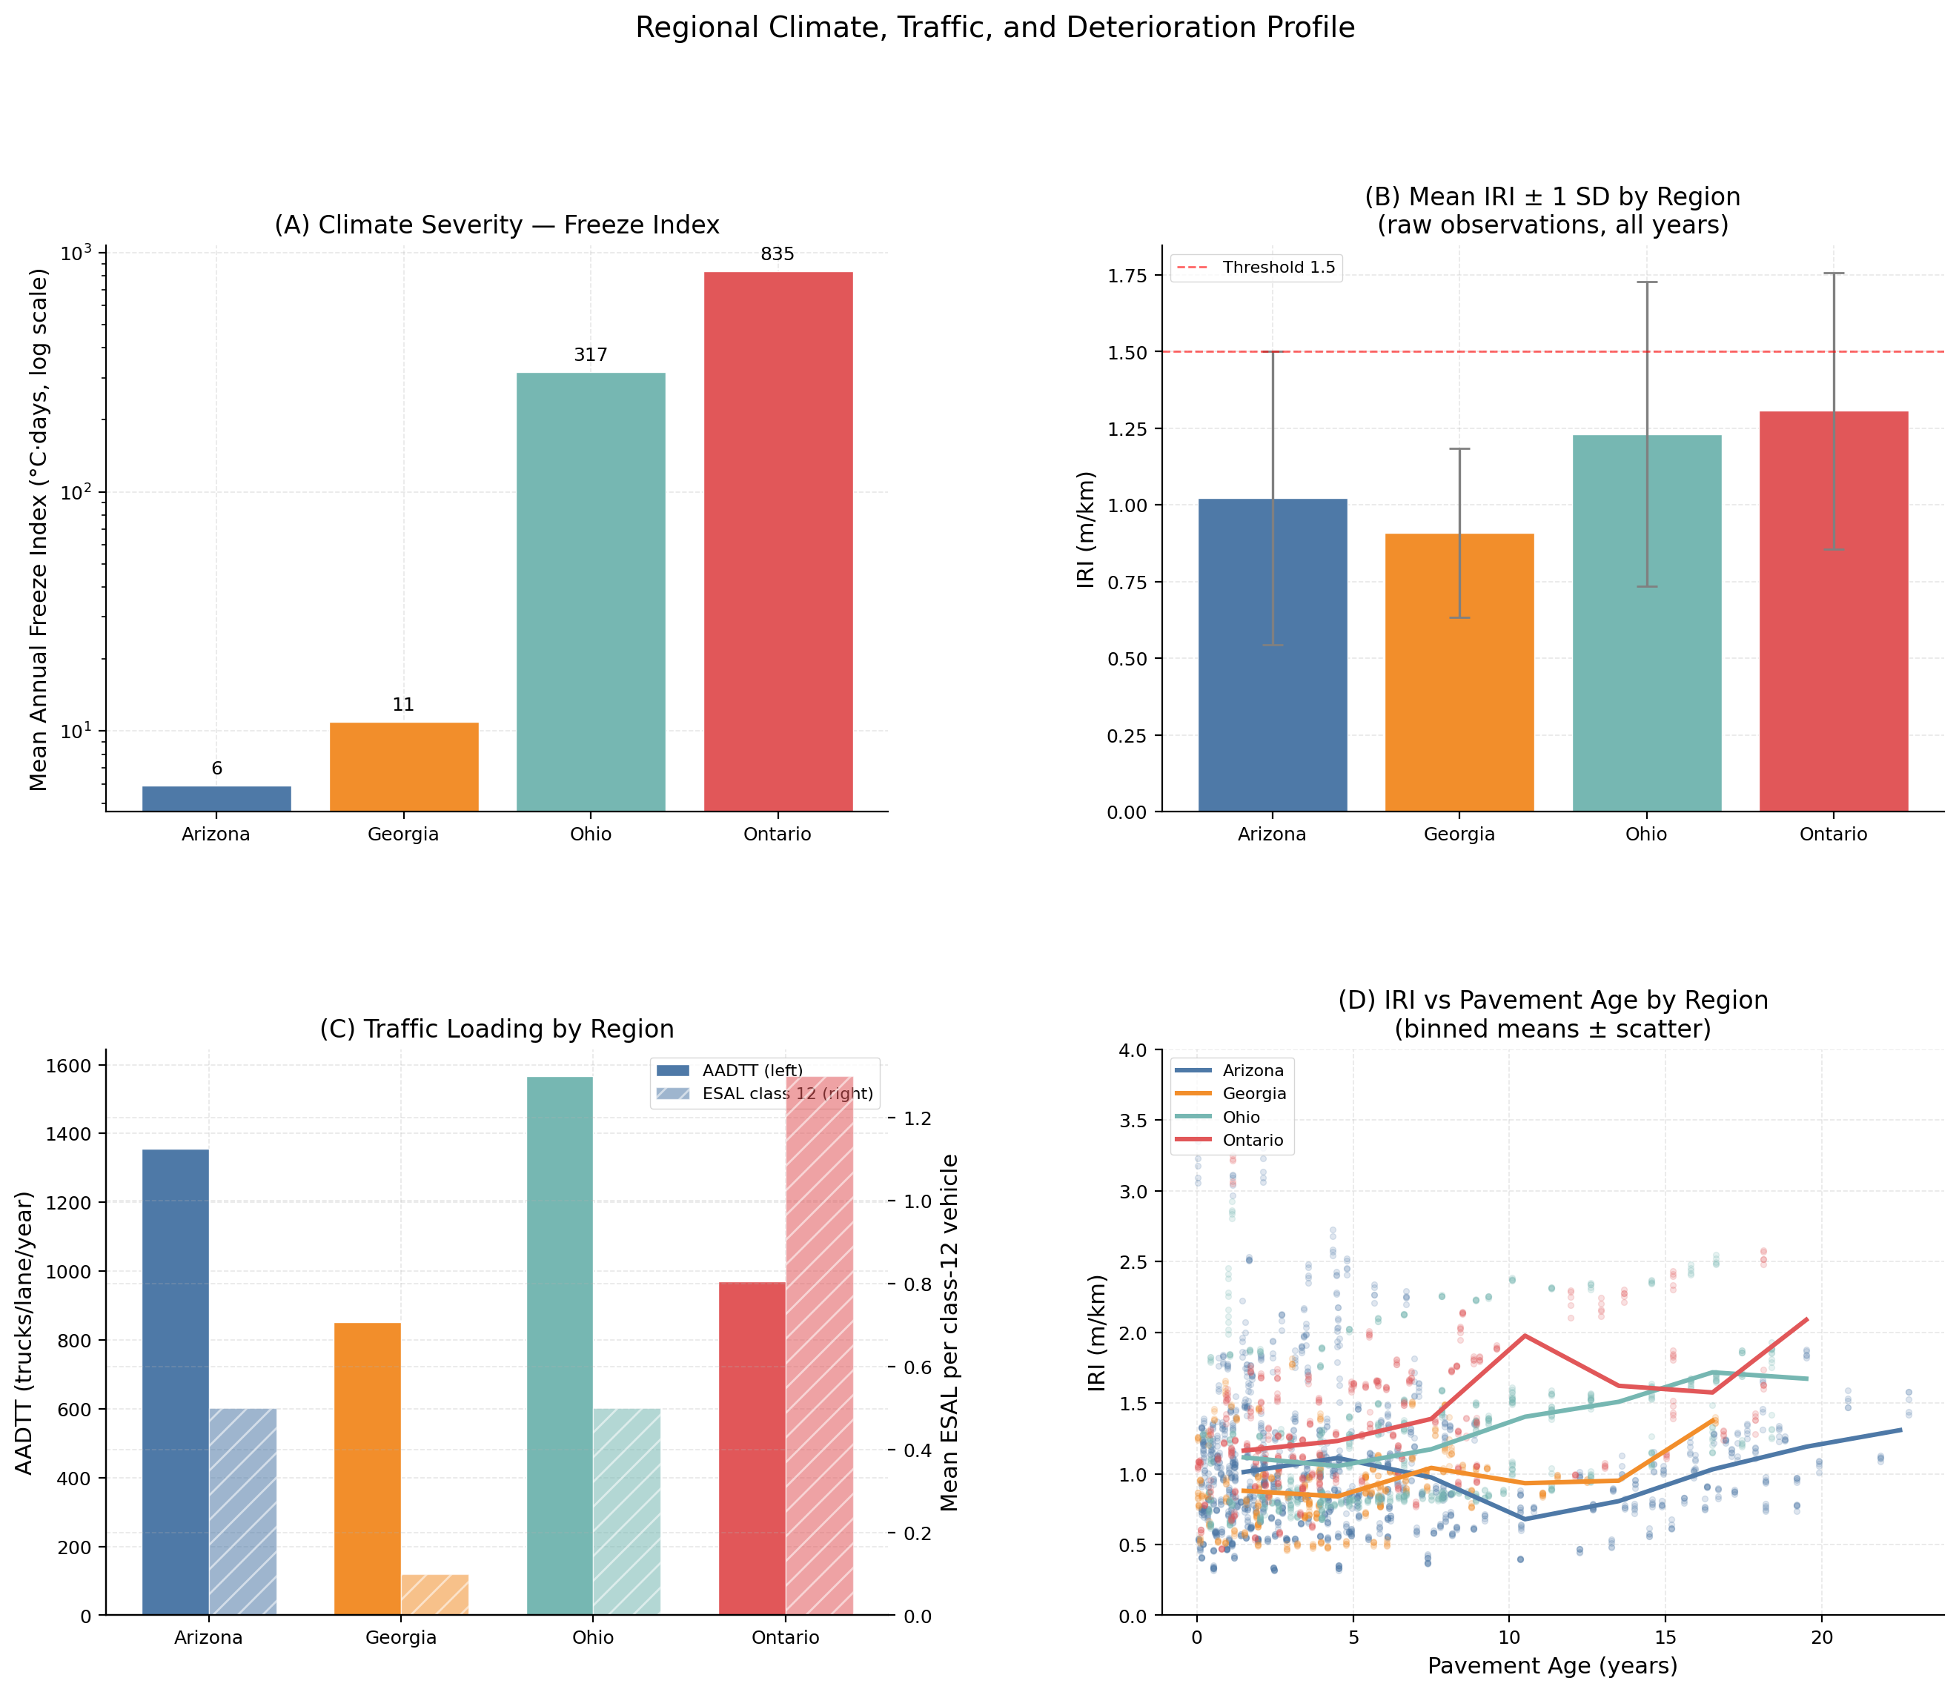
Figure 4.13. Regional climate, traffic, and deterioration profile.

4.11 Synthesis: Limits of Explainable ML for Pavement Prediction (§3.14)
The corrected results support the article's main argument more clearly than the old, overfit chapter. Apparent accuracy can be produced by same-visit condition variables, regional proxies, lag persistence, and bootstrap procedures that do not respect section dependence. Once those shortcuts are removed, design-stage prediction is modest, regional transfer is weak, monitoring must be benchmarked against persistence, and explanations become conditional on model validity.
- Report design-stage and monitoring tasks separately; do not use monitoring accuracy as evidence of design transfer.
- Keep persistence on the same section/date rows as monitoring models whenever forecast skill is claimed.
- Treat SHAP and PDP as diagnostics unless the model passes transfer and stability checks.
- Frame negative LOO results as substantive evidence about limited generalizability, not as a failed side experiment.

